

**Quiz Maker**

January 9, 2020

RaghAV BaJAJ,KRISHAN KYAL,NISHITA BAJAJ

Introduction:

Quiz Contest is an computer application that has general questions related  to current affairs,general knowledge and computer. It has multiple choice questions with time limit of 30 seconds and it also calculate scores of each correct answer.it is good for students of every age group it helps in incresing general knowledge about world, sports and computer etc.

Objective:

The main objective of Quiz generator is to facilitate a user friendly environment for all users and reduce the manual efforts.In past days quiz is conducted manually but in further resolution of the technology we are able generate to the score and pose the

Queries automatically. The functional requirements include to create users that are going to

participate in the quiz and automatic score and report generation.

PROJECT REQUIREMENT AND ANALYSIS :

Requirement analysis is usually the first phase of large scale software development process. The purpose of this phase is to identify the correct requirements of the user. The main purpose of this phase is to understand current system, current problem, expected solutions and functionalities. It is responsible for defining the functional and non- functional requirements for the proposed system. It identifies the constraints on the system operations and development.

Performance Requirements :

The application should be lightweight (low on resources) and high on performance. UI has to be simple in order to achieve that.

Scalability Requirements:

The data that is stored in the database should be updated carefully with new update, if available.

Python :

Python is widely used general purpose, high level programming languague. It was initially designed by guido van russom in 1991 and developed by python software foundation. It was developed mainly for emphasis on code readability and its syntax allows programmers to express concepts in fewer line of codes. Python is a programming languague that lets you work quickly and integrate system more efficiently.

**Features:**

* **Easy to use –** Due to simple syntax rule.
* **Interpreted language –** Code execution and interpretation line by line.
* **Cross-platform language –** It can run on windows,linux,macinetosh etc. equally.
* **Expressive language –** Less code to be written as it itself express the purpose of the code.
* **Completeness –** Support wide rage of library

Sqlite3 :

Sqlite is a self contained , high realibility , embedded , full featured, public domain, sql database engine. It is the most used database engine in the world. It is an process library and its code is publicly available. It is free for use of any purpose, commercial or private. It is basically an embedded sql database engine. It was designed by

D.Richard Hipp for the purpose of no administration required for operating a program.

**Features:**

* Designed to make it relatively easy to add other storage engines.
* Uses a very fast thread-based memory allocation system.
* Executes very fast joins using an optimized nested-loop join.
* Implements SQL functions using a highly optimized class library that should be as fast as possible. Usually there is no memory allocation at all after query initialization.

Use Case Diagram:

A use case diagram is a representation of a user's interaction with the system where relationship is shown between the user and the different use cases in which the user is involved.

Elements in the use case:

1. **Actor:** An actor represents a role that an outsider takes on when interacting with the business system.
2. **Association:** It is relationship between an actor and a business use case association.
3. **Use Case:** It describes the interaction between an actor and a business system.

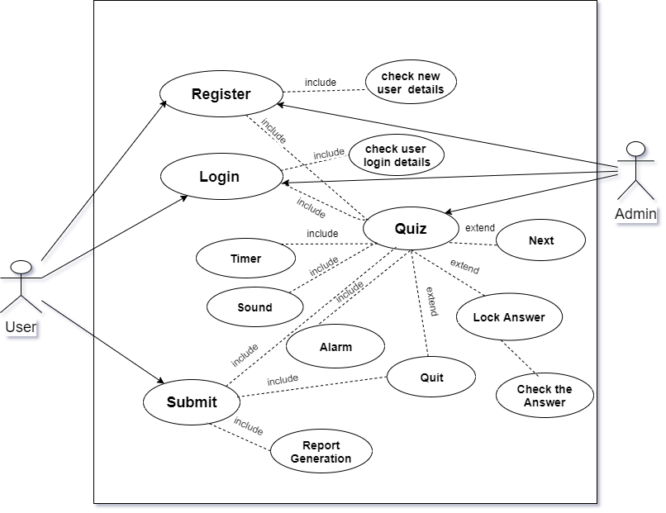

FIG.1 **THE USE CASE DIAGRAM OF QUIZ GENETATOR.**

**DESIGN OF THE PROJECT**

**Project Design & Architecture:**

The aim is to develop an application is to facilitate a user friendly environment for all users and reduce the manual efforts. My Project of includes various frames:

**Libraries Used in Code:**

import PySimpleGUI as sg

import pandas as pd

import numpy as np

import wikipedia

import pyttsx3

import matplotlib.pyplot as plt

import sqlite3

import time

import pygame

from PIL import Image

import time

from reportlab.pdfgen import canvas

from reportlab.platypus import SimpleDocTemplate

from reportlab.lib import pdfencrypt

from reportlab.lib.units import inch

from reportlab.platypus.tables import Table, TableStyle

from reportlab.lib.pagesizes import letter

from reportlab.lib import colors

import datetime

**Requirements & Comparisons**

Hardware requirements:

Our project requires following hardware requirements to work to its full potential :-

Computer system :

1. 4 gb ram
2. 300GB Hard-Disk

Software Requirements:

**For Development Purpose:-**

1. IDE:Jupyter notebook

2. Database: SQLite3

3. Platform :Python

4. Graphics:draw.io (Usecase)

**For Work Station:**

1. PC
2. Tablet with Windows OS

Conclusion:

This academic minor project work proved so much beneficial for us as we were able to learn about some advanced paradigms of computer technologies. We learned about application development and database management.Ultimately we were able to design a application for storing passwords and web history which also provide backup and restore.

BIBLIOGRAPHY:

Books:

Introduction to GUI Apps .

Python By Sumita arora Complete reference.

Web-Pages:

* SQLite Query
* database connectivity (Youtube Channel)
* Report Generation by Reportlab (Youtube Channel)